Eg: String_Eg76

When you try to print object reference, internally .toString() is called on it to print the reference . but manually we had written toString() which returns null value. so it is added to “text” variable.

Eg: String_Eg77

// go through the code, it is based on above program String_Eg76.

Eg: String_Eg78

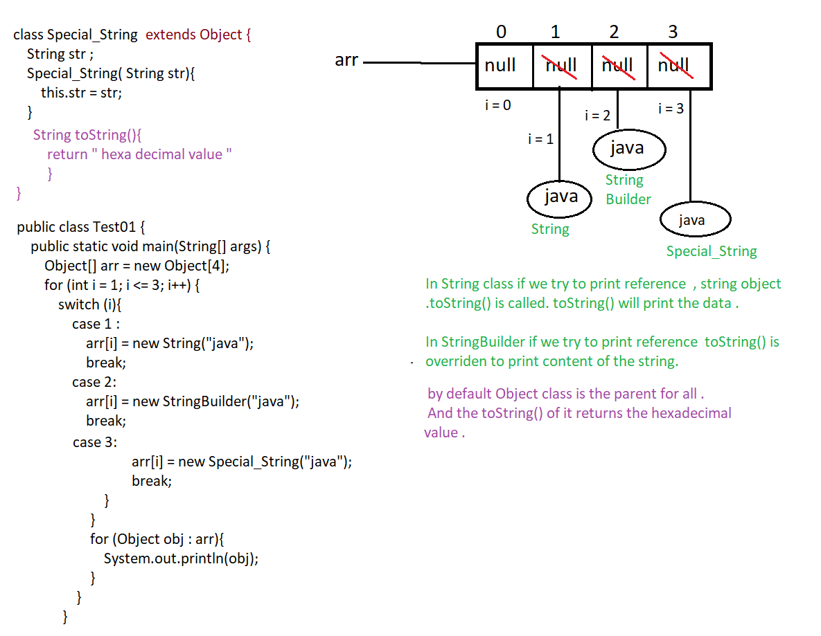

Eg: String_Eg79

// go through the command.

Eg: String_Eg80

// go through the code.

Eg: String_Eg81

// go through the code.

Eg: String_Eg82

// go through the code.

Eg: String_Eg83

// go through the code.

Eg: String_Eg84

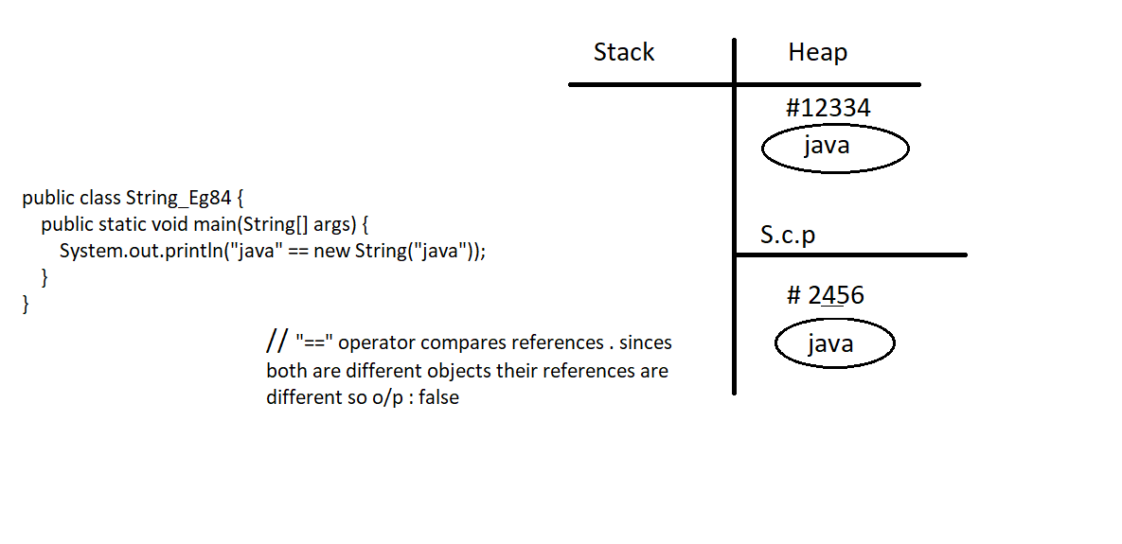

Eg: String_Eg85

// go through the code

Eg: String_Eg86

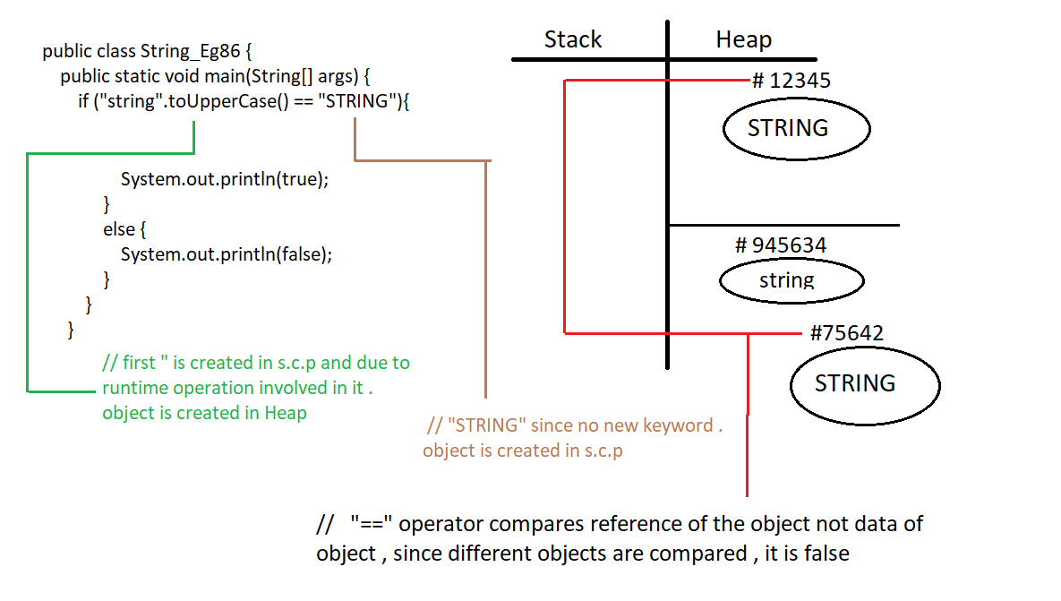

Note : String , StringBuilder , StringBuffer all these classes are final by default.

Eg: String_Eg87

// go through the code.

Note: When the string concatenation is very frequent and code is need not be thread safe, we can opt for StringBuil0der(1.5v)

Eg: String_Eg88

//go through the code.

Eg: String_Eg89

// go through the code

Eg: String_Eg90

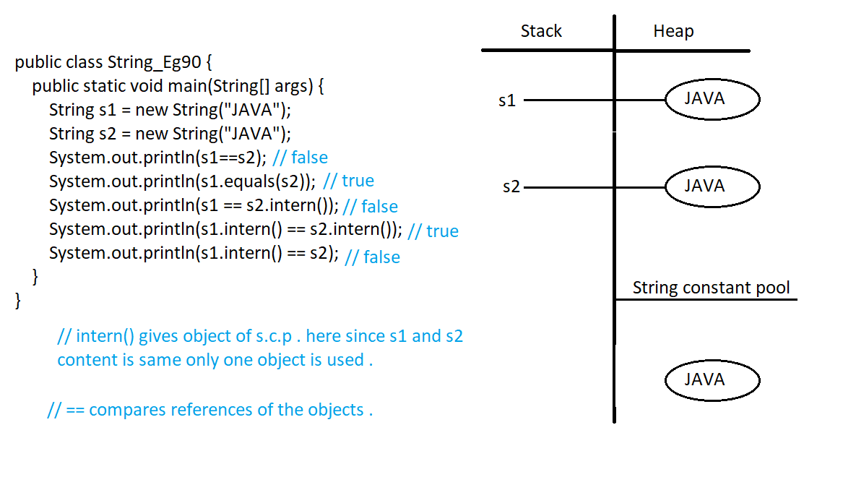

Eg: String_Eg91

// go through the code .

Note : StringBuilder( ) constructor different types of parameters , check it in the IDE.

Eg: String_Eg92

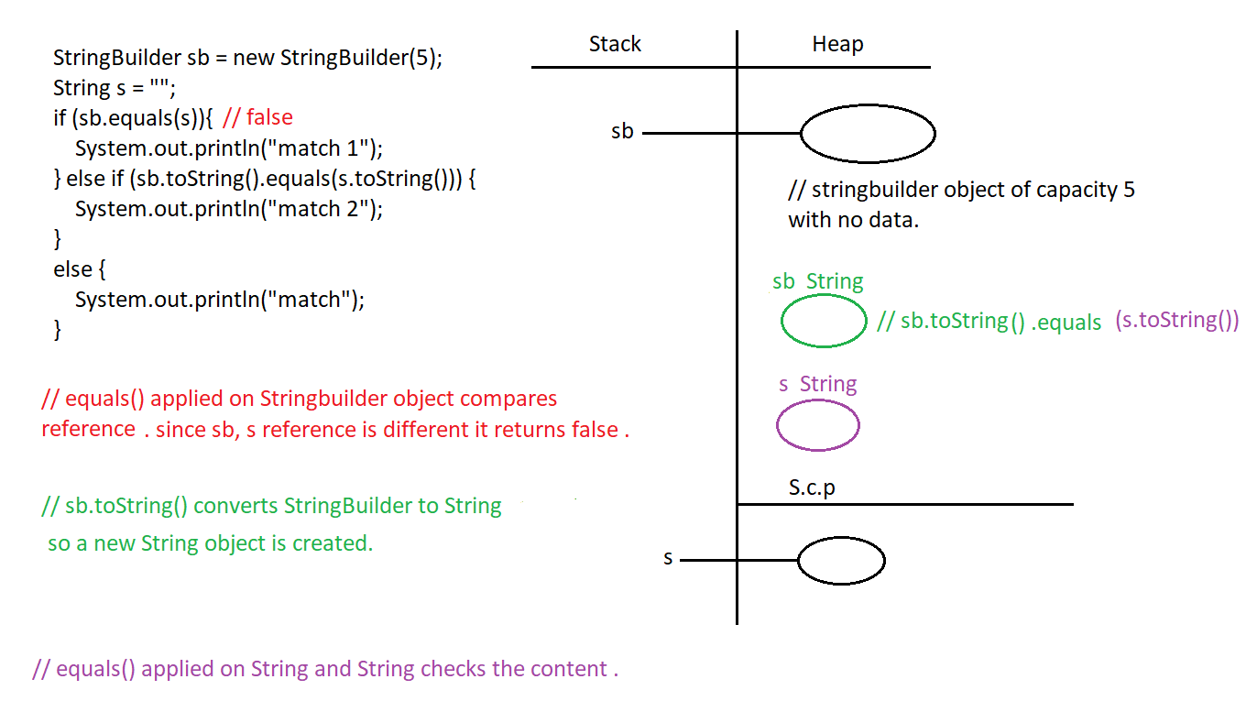

Eg: String_Eg93

// go through the code.

Eg: String_Eg94

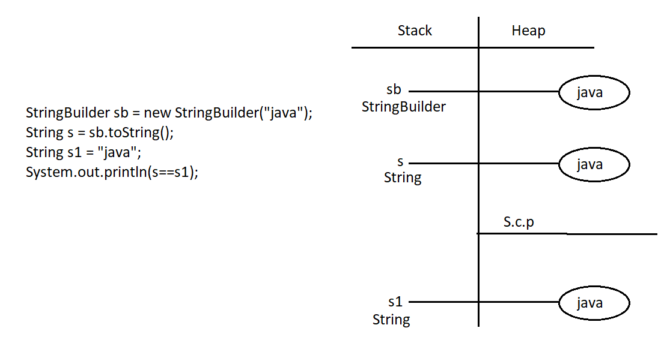

Eg: String_Eg95

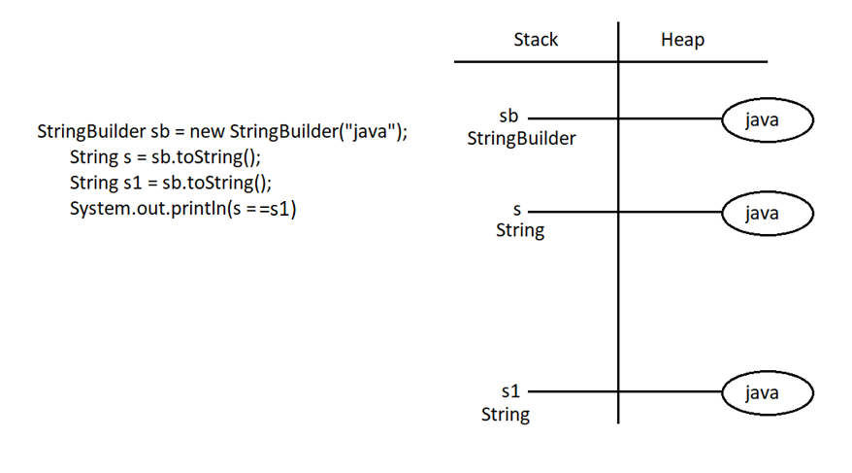

Eg:String_Eg96

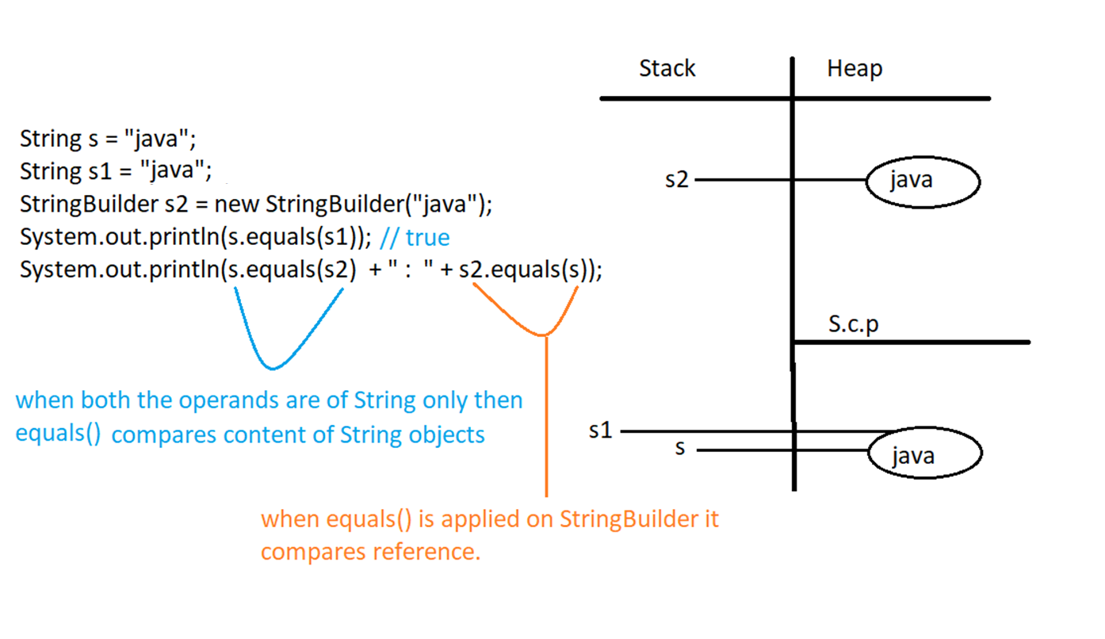

Eg: String_Eg97

// go through the code.

Eg: String_Eg98

// go through the code

Eg:String_Eg99

// go through the code

Eg: String_Eg100

// go through the code

Eg: String_Eg101

// go through the code.

Eg: String_Eg102

String is not wrapper class it is a Object.

Here i2 is a wrapper class , even though wrapper classes is final memory for them is given at the runtime . if run time operation is present jvm is involved , and memory for them is allocated in the heap.

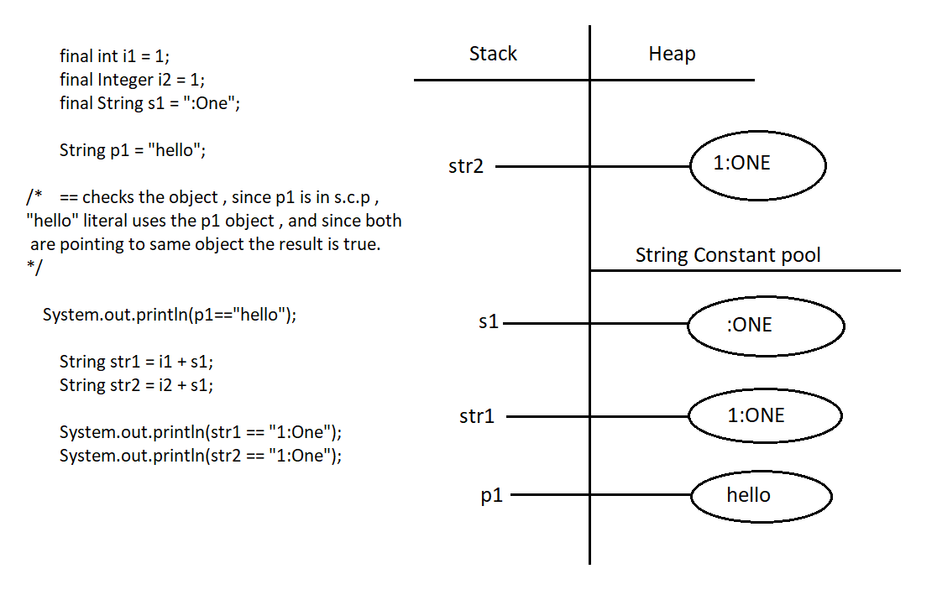

Eg: String_Eg103

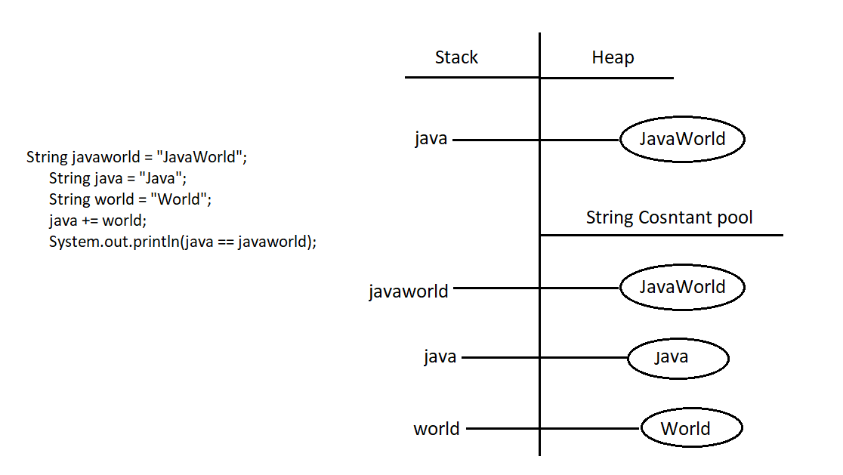

Eg: String_Eg104

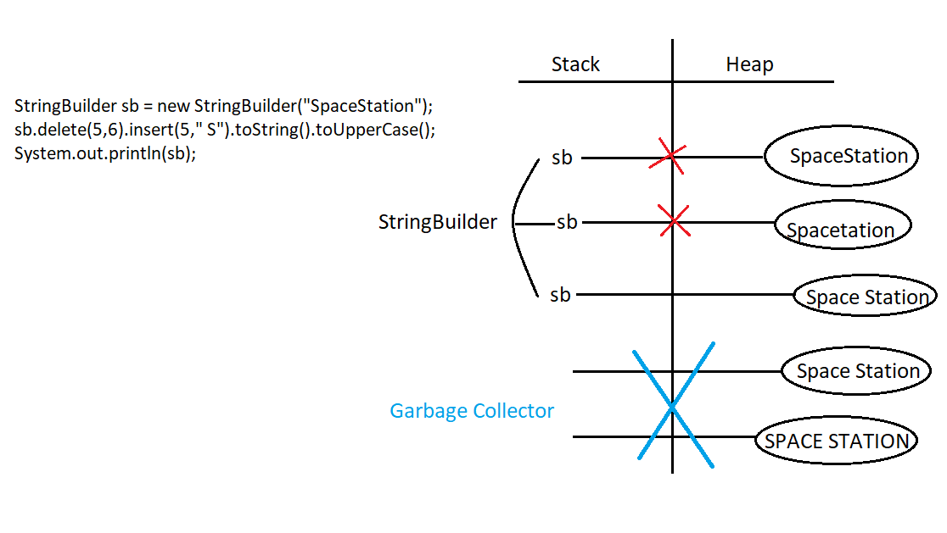

Here for StringBuilder sb same object is updated, if we try to update it / make changes to it. no new object is created.

But in String a new object is created if we try to make a change / update, and if the updated one is not collected using variable, garbage collector will clear it .

Eg: String_Eg105

// go through the code

Eg: String_Eg106

In the heap area when there is no reference and you are trying to use that, jvm maintains the reference using “this” keyword.

Current object will always be pointed by two references, one is our object reference, and the other is jvm internally maintained object reference through “this” keyword.

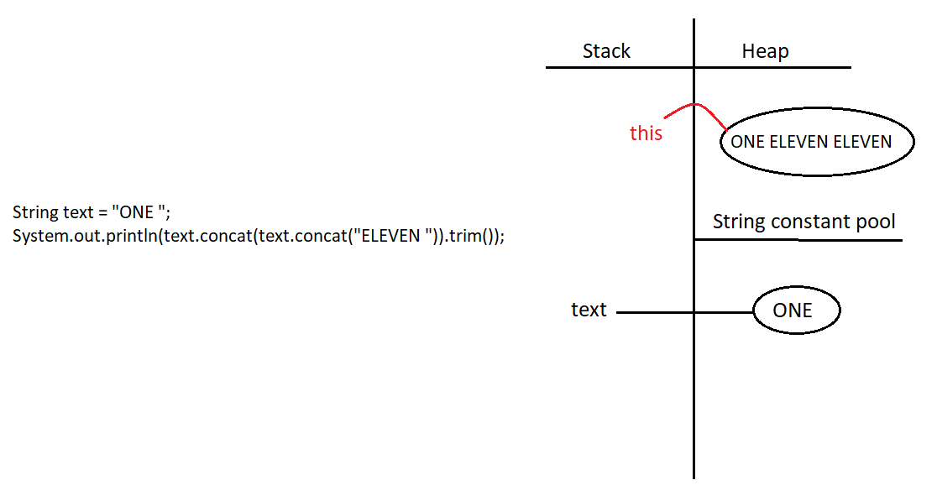

Eg: String_Eg107

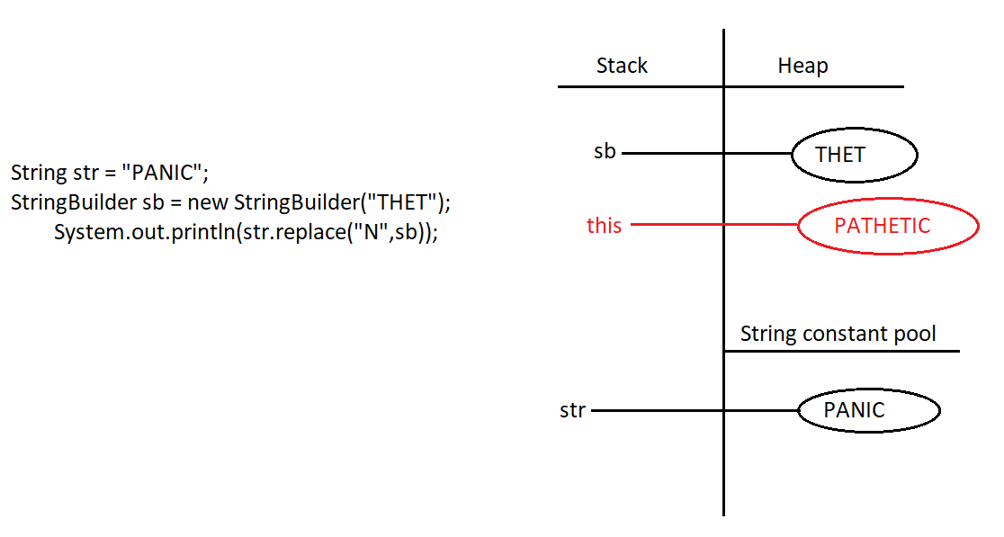

Eg: String_Eg108

// go through the code

Eg: String_Eg109

// go through the code

Eg: String_Eg110

indexOf() method the index of string object starts from 0. 1 is added to it so 2. charAt() method index also starts from 0 so chartAt(2) = > V

Eg: String_Eg111

// go through the code

Eg: String_Eg112

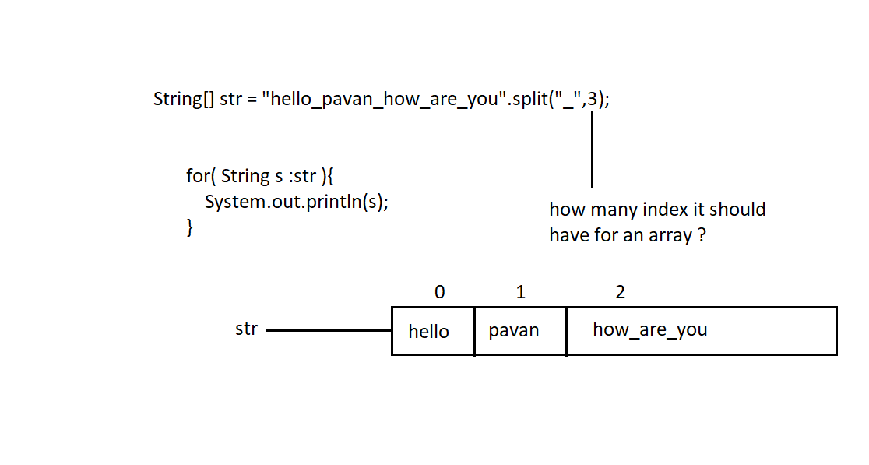

If we don’t give array size , wherever “_” is found in the string object, the array will have that many no of indexs.

Note : java.lang.String class implements the following interfaces

Serialzable

CharSequence

Comparable (check this when interface concept completed).

Which of these classes have delete() and reverse() method

A) java.lang.String B) java.lang.StringBuilder c) java.lang.StringBuffer

Answer: B & C

Note: methods present in StringBuilder are also present in StringBuffer also.